INVITATION TO TENDER

Evaluating the impact of The National Lottery Community grant for FareShare

1. Aim 3
2. Background 3
3. Aims and Objectives 5
4. Methodology 6
5. Considerations 7
6. Deliverables 7
7. Internal responsibilities and liaison 8
8. Required skills and knowledge 8
9. Timetable for delivery 8
10. Budget 9
11. Award Criteria 9

Appendices

Appendix A: Fareshare Theory of Change

Definitions of FareShare terminology

FareShare Network: FareShare Regional Centres and FareShare Go
Network Partner/Regional Centre: Redistributing FareShare’s food, 18 are independent charities, 3 are run directly by FareShare UK
Member: Charities paying a fee and receiving food from a Regional Centre
Associate: Charities signed up to FareShare Go receiving food by collecting it from their local supermarket.

Aim

In April 2018 FareShare received funding from the National Lottery Community Fund (TNLCF) to increase the management capacity needed to manage more food and volunteers.

Following on from a previous external evaluation of this project which covered 2018-2020 and reported in Jan 2021, we are commissioning a final external evaluation to review the transformation FareShare has gone through in the past 3 years since TNLCF investment and identify what has worked well, less well and what could be improved and changed so that FareShare can continue to develop its strategy and services.

Background

FareShare exists because millions of people across the UK are struggling to afford to eat, yet at the same time thousands of tonnes of good food goes to waste every day. FareShare works across the UK to intercept quality, in-date and good to eat surplus food, and redistribute it to charities and community groups working with vulnerable people including children, the elderly, those who are homeless or struggling with physical or mental health difficulties.

FareShare works with 18 independent charity partners across the UK, from Devon and Cornwall to the Highlands and Islands of Scotland. Between them these partners are experts in employability, volunteering, recycling, homelessness, housing, poverty and children's services, as well as food redistribution. They all work to high standards of food and people safety and make sure that the food redistributed does as much social good as possible. Working with over 2,000 volunteers, they redistribute 48,000 tonnes of food, through 29 warehouses to 1,000’s of charities six days a week.

FareShare UK supplies food to the Network Partners for free and provides business support to our 18 partners as well as managing 3 Regional Centres and charity collections from Tesco, Waitrose and ASDA stores.

FareShare’s Regional Centres redistribute the food safely to the charities and community groups (which we call members) that most need it, delivering community development through food across the UK.

FareShare Go is a separate service which provides charities and community groups (which we call associates) with direct access to surplus food from local supermarkets, including Tesco, ASDA and Waitrose & Partners. Since launching the scheme in 2015, we have already connected over 7,500 charities with more than 3,500 stores across the UK.

In 2020/21 FareShare redistributed 55,046 tonnes of food (an increase of 132% from 19/20) to 10,542 charities and community groups.

The impact of the TNLCF project (and infrastructure-building funding which complimented it) has been to transform FareShare from a small charity to a medium-sized one, and that has been multiplied and cemented by the increase in our operation during the Covid-19 pandemic. The organisation is at a pivotal point in our development, as we review this transformative project and consider our future role and plans. We have undertaken a major strategy review and are moving into the planning stage. This evaluation will feed into that planning and ensure that we fully understand the impact of TNLCF investment in our Regional Centres, and also investigate what we want to further develop within our Network and among our beneficiaries, to maximise the social value of surplus food.

FareShare Vision, Mission and Values

Vision: We have the vision of a UK where “No good food goes to waste”.

Mission: To use surplus, fit for consumption, food to feed those who are vulnerable in the UK by supporting front line charitable organisations that tackle the cause and not just the
symptoms of food poverty.

Our Values
Passion – for our cause and the challenge that lies ahead
Ambition – to go the extra mile and drive the change that must happen
Respect – for ourselves, each other, our volunteers, our partners and our beneficiaries
Collaboration – it’s only by working with others that we can be stronger
Focus – on providing the best service possible so that we deliver and achieve the most for our clients/customers

FareShare and the National Lottery Community Fund partnership

We received funding for three years from National Lottery Community Fund in April 2018 to help us increase our capacity, effectiveness and local knowledge, to deliver more food to more community organisations and to increase the number of volunteers supporting FareShare. The project was extended by six months and will come to an end in September 2021.

The main areas of investment included increasing management capacity at FareShare UK and its’ redistribution centers, volunteer recruitment & retention, monitoring and evaluation and IT. Activities included:

• Undertaking a UK wide volunteer recruitment through the roll out of a centralised volunteer management and communication system and associated partnerships and media campaigns.
• Increasing volunteer numbers by 300 focused in areas of high social deprivation.
• Increasing staffing across the 21 Regional Centres to deliver the increased growth and efficiency of each centre and reach an additional 5,040 new VCSE organisations. Each centre defined their own staffing needs, but in most cases the funding provided additional capacity to manage the increase in food and VCSE organisations supported, and specific volunteer management to greatly improve the volunteer journey;
• Increasing staffing at FareShare UK across the following functions: volunteering, organisational development, marketing and brand, partnerships, food and operations and Impact & Evaluation.
• Investment in internal and external monitoring and evaluation to greatly improve the ability of FareShare to evidence the impact of its work.
• Investment in IT systems and staffing, creating an integrated customer relationship management system that links food, customers, funders and investments.

Overall, the funding has enabled FareShare UK to transition into a medium sized charity and develop the governance, managerial, monitoring and evaluation and operational systems and processes needed to successfully increase the service provided to our community, and the involvement of the community through volunteering.

These organisational changes are measured through outcomes which reflect their operational impact – food provided, charities served, money saved by charities, volunteers engaged, and sustainability achieved.

FareShare Theory of Change

As part of the investment in our monitoring and evaluation we were able to develop a FareShare Theory of Change and an Impact and Evaluation Framework (Appendix A). This allowed us to identify a number of outcomes that we will be measuring:

- Charities and community groups have financial savings they can re-invest in the services they provide.
- Charities and community groups are able to reach more people.
- Charities and community groups provide more services.
- Beneficiaries are able to connect with others.
- Charities and community groups get access to: more food, more variety, better quality & more nutritional value.
- Beneficiaries experience new foods.
- FareShare has the right amount of volunteers and volunteer hours to meet the organisational need.

Aims and Objectives

Looking at the network wide changes as a result of TNLCF investment, identify lessons and recommendations to enable Fareshare to embed and develop its strategy, model and approaches.
- Identify trends in ways of working that have helped and hindered network partners to get to where they are now as a result of the additional resources the funding provided, identifying areas of good practice, opportunities and barriers.
This should cover the main areas of activity of the funding:
  - Volunteering – recruitment and management
  - Increased staffing across 21 regional centres
  - New IT Systems: CRM, Learning management for staff and volunteers across the network

- Identify trends in ways of working that have helped and hindered network partners to get to where they are now as a result of the additional resources the funding provided, identifying areas of good practice, opportunities and barriers in relation to the ability to demonstrate using food to maximise social value.

This should include consideration of the outcomes from the Theory of Change and analysis of data and information FareShare currently hold including (but not limited to) the most recent 2021 annual survey. More information on the data available is provided in the methodology section below.

- How do delivery partners monitor and evaluate their social value?
- How can FareShare UK refine its monitoring, evaluation and learning to improve reporting on social value, assess the extent to which it is meeting needs and support delivery partners and members.

In both areas identify trends, good practice and areas for development for both Fareshare UK and network partner organisations.
We expect you to:
- Serve as an independent expert on evidence and evaluation.
- Provide analysis of findings, identifying trends and lead on providing insights and recommendations alongside relevant stakeholders.

Methodology

We anticipate that the evaluation will draw on a range of evidence both quantitative and qualitative, including primary and secondary sources and take participatory and equity-based approaches. Interviews, focus groups, workshops, surveys and data analysis should be considered. We do not want to prescribe specific methods, we would like consultants to set out proposals for a detailed methodology based on your knowledge and expertise.
We anticipate that the work will involve, to some degree, the views of relevant staff and volunteers across FareShare UK and 18 delivery partners which form the FareShare network. This includes:
- Our regional centres are the experts on their own operations and have regional knowledge so it is essential they are central to the evaluation.
- Staff at various levels throughout the various organisations of the Network, not only senior or managerial staff.
- Volunteers from across the network.
- Involvement from Fareshare UK and regional centres in developing findings and recommendations. We believe those closest to the work are well placed to inform findings and recommendations to ensure they are relevant, adopted and acted on.

Review and analysis of datasets Fareshare holds.
The focus of this evaluation is to understand how FareShare works with its’ delivery partners and the community organisations so there will be a requirement to get an in-depth understanding of any themes arising from existing data.
FareShare has varied quantitative data from recent internal and external evaluations, together with detailed operational data on food distributed and the organisations receiving it. We have not had the capacity to make use of the data for evaluative purposes. We would like the evaluation team to review all existing data and identify the most appropriate methodology to gather additional information to answer the questions above.
FareShare will be able to provide the following data:
- Quantitative data from our operational systems including but not limited to: food volumes and details about the community groups supported by FareShare (location, organisation characteristics, food service profile, volumes of food received, etc.), food offers and the allocation of products across the Fareshare network, and relevant volunteer data including hours.
- Recent and previous annual surveys conducted with community organisations for 2020 and 2021.
FareShare will able to provide the following reports:
- An external evaluation (Jan 2021) looking at the impact of TNLCF funding on FareShare.
- Volunteering Programme Evaluation Report

Considerations

FareShare only manages directly 3 out of the 21 regional redistribution centres, the others are separate organisations. Therefore, access to staff and charities will depend on our partners’ availability and co-operation.
With over 10,000 members the sample of members for this evaluation will have to be representative of the wide variety of charities FareShare supports.

Deliverables

Audiences
The outputs should consider the intended audiences to ensure the information is conveyed in the most appropriate and engaging way. The results of the evaluation will be read by:
Primary: Participants from across the network. Fareshare UK Senior Leadership Team, Impact Steering Group (Fareshare UK), Project Evaluation Steering Group (Fareshare UK), Fareshare UK departments leadership teams, The National Lottery Community Fund.
Secondary: All Fareshare UK staff, Network Partners

Outputs
We expect the following deliverables from this evaluation:

- A summary report of all the findings and recommendations, in a format to be agreed.

- A report in Word format. This should include findings, lessons and recommendations to inform FareShare’s future developments and to inform the funder on the impact of their funding.

We aim to ensure the evaluation findings are read by everyone within Fareshare UK, therefore we require reporting in formats which provide the appropriate amount of detail and insight while remaining concise, digestible, accessible and engaging.

Internal responsibilities and liaison

FareShare will provide all relevant information from previous evaluations and the data necessary to carry out this evaluation. There will be a dedicated liaison person at FareShare, the Impact & Evaluation Manager, who will introduce the evaluation team to the relevant stakeholders; facilitate access to FareShare UK teams and charities, redistribution centres and support with any arising issues.

Timetable for delivery

A project plan with specific deliverables and timetable will be agreed with the successful consultants. However, we expects these deliverables in accordance with the following timetable:

Activity | Timeline
Deadline for bids | 18 June 5pm
Interviews | w/c 21 June
Inform successful bidder | Thur 24 June
Set up meeting | w/c 5 Jul
Draft report | w/c 18 Oct 2021
Submission of final report | 29th October 2021

  - Regular check-in meetings at key milestones will be agreed once the workplan is finalised.
- All outputs must consider accessibility needs. In all outputs, the creative use of design and visualisation to increase comprehension and conciseness will be valued.
  - All reports to include appendices as agreed between Fareshare and the contractor. The contents and structure of the report to be agreed in advance of writing. All reports to be supplied in electronic format.
  - The successful bidder must comply with all the requirements of the Data Protection Act 2018 and shall ensure appropriate research consents from interviews or any data collection.

  - The successful bidder will be expected to discuss and present findings at appropriate times, to internal audiences. The purpose of these presentations is to enable lessons to be learned and key policy and practice issues to be highlighted.

  - We expect all research and evaluation projects we fund to adhere to the Social Research Association (SRA) ethical guidelines. If your proposal raises particular ethical issues, you must indicate what they are your strategy for addressing them.

Budget

The budget for this project is up to £50,000 (inclusive of VAT).

Award Criteria

We will be asking for proposals from several different bodies to ensure that the process is competitive.
For the selection process we would like you to submit:
- A proposal of a maximum of 10 pages (excluding appendices)
- One example of an evaluation report and/or presentation
The proposal should contain the following:
- a detailed method for undertaking the study;
- An explanation of how you will work with FareShare in delivery of the project to ensure that FareShare needs are met.
- details of staff allocated to the project, together with experience of the contractor and staff members in carrying out similar projects. The project manager / lead contact should be identified;
- the allocation of days between members of the team;
- the daily charging rate of individual staff involved;
- a timescale for carrying out the project;
- an overall cost for the work.
- Description of the quality assurance systems that would be applied during delivery of the project and how data protection requirements will be managed.

Selection Criteria
Demonstrates a knowledge of the UK charity landscape and the issues facing front line service delivery organisations

Demonstrates an understanding of the FareShare Network operating structure and organisational development needs.
Demonstrates an understanding of the social value of food.
Demonstrates that the methods selected are appropriate to the research requirements set out in this brief as they relate to challenges that may be present when conducting research remotely.
Demonstrates a record of producing high quality evaluation outputs to contribute to organisational learning and strategy development, with a track record of communicating findings in a creative and concise way, appropriate to their intended audiences.

Appendix A

FARESHARE THEORY OF CHANGE
September 2019

Executive summary
FareShare has been working in partnership with NCVO Charities Evaluation Services (NCVO CES) to develop a theory of change and an impact and evaluation framework. This work will help FareShare to articulate its impact and form the basis for any future impact evaluation work.
The theory of change consists a map and a narrative describing FareShare operation and how it leads to desired outcomes and broader societal impact. It helps to better understand and communicate what change is desired or expected from the activities undertaken by the organisation. As well as supporting evaluation, theories of change can help organisations and services understand the work they do and communicate their purpose. More information about theory of change is available here.
The map and the narrative described in this document explain how FareShare addresses the problem of ‘surplus food is not being used in the most socially and environmentally beneficial way’ to achieve its ultimate impact:
- To maximise the social value of surplus food to better support individuals to improve their physical wellbeing, mental wellbeing, social inclusion, and food security.
- To reduce the negative environmental impact of surplus food.

It details the main organisational activities and the short term, medium term and long term outcomes achieved by its’ operation that all feed into achieving the impact above.
Developing the theory of change helped identifying the outcomes that FareShare has a direct impact on and would like to measure:
- Food using organisations (community and charity groups) have financial savings they can re-invest in the services they provide.
- Food using organisations are able to reach more people.
- Food using organisations provide more services.
- Beneficiaries are able to connect with others.
- Food using organisation get access to: more food, more variety, better quality & more nutritional value.
- Beneficiaries experience new foods.
- Reduced CO2 emissions.
- Reduced wastage of surplus food and the resources related to its production.

These outcomes will form the basis of FareShare impact evaluation framework and will guide all of FareShare evaluation work. Following this work FareShare will be able to implement internal impact measurement, reducing our reliance on external evaluations and providing FareShare with regular up-to-date data that can be used for organisational learning & improvement, fundraising and marketing.

FareShare’s theory of change

Map
The current diagram contains the details discussed at the workshop and follow-on internal consultation at FareShare. This diagram should be looked at alongside the narrative bellow that provides the details for each of the maps components and the logic behind it.

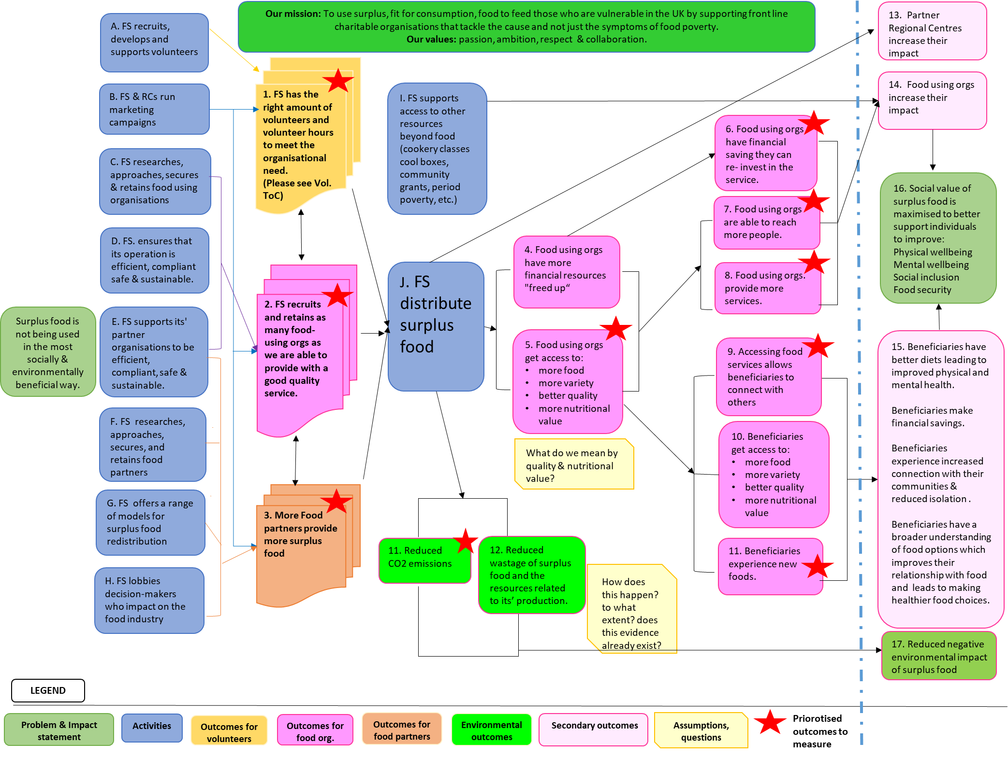

Narrative
The narrative is an explanation of the map. In the map we use boxes to represent the key aspects of the theory that it sets out, namely its activities and outcomes for various stakeholders. These boxes are labelled with either letters or numbers. These are referenced in [square brackets] throughout this document. The narrative follows the map from the problem statement on the left to the impact statement on the right. Details on the definitions and terms used in this document are available in Appendix A.

Problem statement
The problem that FareShare is set up to solve is that ‘surplus food is not being used in the most socially & environmentally beneficial way’.

Activities
Activities are the various areas of work FareShare engages in to accomplish its intended changes – what FareShare does in to reach the ultimate goals of maximising the social value of surplus food, whilst reducing the negative environmental impact of surplus food. Some of these are direct external-facing activities, whilst others are internal processes necessary for successful operation.
As FareShare’s food redistribution system is largely operated by volunteers, the organisation engages in recruiting, developing and supporting volunteers [A].
To engage with and support potential food using organisations (charities or community groups), FareShare researches, approaches, secures, and retains food using organisations [C] to find new opportunities to help these organisations by providing them with surplus food. To achieve this, FareShare also ensures that its operation is efficient, compliant, safe and sustainable [D]. They also support partner organisations (such as many Regional Centres) to also have efficient, compliant, safe and sustainable operations [E].
Other partner organisations include food partners that FareShare sources surplus from. To build and main working relationships with these companies, FareShare researches, approaches, secures and retains them [F]. FareShare offers a range of models for surplus food redistribution and potential partnerships [G] in order to recruit and retain these food partners, and help them to embed processes and systems to safely divert surplus food to charities. FareShare also lobbies decision-makers who impact on the food industry [H] to further incentivise food partners to maximise the social value, and minimise the negative environmental impact of surplus food going to waste by working with FareShare.
In order to recruit volunteers, food using organisations and food providers, FareShare and its Regional Centres run marketing campaigns [B].

Short term outcomes
These activities all enable FareShare to achieve its short term outcomes:
- FareShare has the right amount of volunteers and volunteer hours to meet the organisational need [1]
- FareShare recruits and retains as many food using organisations as they are able to provide with a good quality service [2]
- More food partners provide more surplus food [3]

These outcomes are each the end-point of longer processes. For example, other intermediate outcomes not described in this theory happen between FareShare’s recruitment, development and support of volunteers [A] and FareShare having the right amount of volunteers and volunteer hours to meet organisational need [1]. Whilst this organisation-wide theory of change does not focus on these elements, they are viewed as ‘nested’ theories, each with their own theory of change. The end-points of these ‘nested’ theories are outcomes 1, 2, and 3.
The volunteer recruitment and management theory of change (‘nested’ within outcome 1) was developed by Insley Consulting in 2018. The details of the food using organisation recruitment theory and the food partner recruitment theory are to be agreed by FareShare at a later date.

Service delivery activities
All activities and short term outcomes are conducted to enable FareShare to deliver its core function: distribute surplus food [J]. This is where FareShare’s operational focus is to deliver its outcomes.
In addition, FareShare uses its infrastructure to support access of food using organisations to other resources beyond food [I], such as cookery classes, cool boxes, community grants and sanitary products. FareShare’s operational outcomes depend on the successful delivery of surplus food distribution.
These intermediate and long-term outcomes are described next.

Social Outcomes

5.1 Intermediate outcomes
As a result of FareShare redistributing surplus food [J], food using organisations (charities and community groups that work with FareShare) will have more financial resources “freed up” [4]. They also will have more food and/or a better variety, quality and nutritional value food [5] than they would otherwise be able to access – the food that FareShare provides is often commercially out of reach for charities and community groups with restricted budgets available for food purchase.
These intermediate outcomes enable the long-term outcomes described below.

5.2 Long-term outcomes and contributions

For food using organisations:
More “freed up” financial resources mean that the food using organisations will make more financial savings that they can re-invest in the service [6]. With more resources available along with more food and/or better variety, quality, and nutritional value of food, food using organisations are able to also reach more people [7] and provide more services [8].
In addition, FareShare supports these organisations to access other resources beyond food [I].
Thus, in the long term, FareShare contributes to the ability of food using organisations to increase their own impact [14].

For beneficiaries:
By enabling food using organisations to access more food, and/or use a better variety, quality and nutritional value of food in their services, FareShare directly enables outcomes for the beneficiaries (service users) of these charities and community groups: using food services provides beneficiaries with the opportunity to connect with others [9], they receive more food and/or more variety, better quality of food and foods with more nutritional value [10]. They also experience new foods that they otherwise may not be able to access [11].
Whilst further outcomes for beneficiaries depend on many factors not within FareShare’s remit, these outcomes do contribute to beneficiaries having better diets leading to improved physical and mental health, making financial savings, experiencing increased connection with their communities and reduced feelings of isolation, and/or making healthier food choices due to having a broader understanding of food options and an improved relationship with food [15]. The link between the experience of new foods and the longer-term benefits for beneficiaries is currently being explored in research by DR Megan Blake.

For Regional Centres:
FareShare’s distribution model involves three Regional Centres run by the core organisation and 18 Regional Centres managed by independent charities. These 18 charities have their own goals which being a FareShare Regional Centre contribute to. By supporting these charities in working as part of the food redistribution chain, FareShare contributes to these partner Regional Centres’ increasing their own impact [13].
The three secondary impact areas identified above (13, 14, and 15) all link into FareShare’s ultimate impact of maximising the social value of surplus food [16] which is detailed in the impact section in this document.

Environmental Impact
By reducing the amount of surplus food going to waste, FareShare’s work addresses the negative impact of surplus food on the environment; the model of surplus food redistribution was inherently created with environmental benefits in mind.
Food waste has a damaging effect on the environment, primarily due to the greenhouse gas emissions from transportation and landfill – moving food waste results in carbon emissions, and as food breaks down it releases methane, a potent greenhouse gas. A huge amount of energy, nutrients and water goes into growing, storing, packaging and distributing food. When surplus food goes to waste, so do these resources.
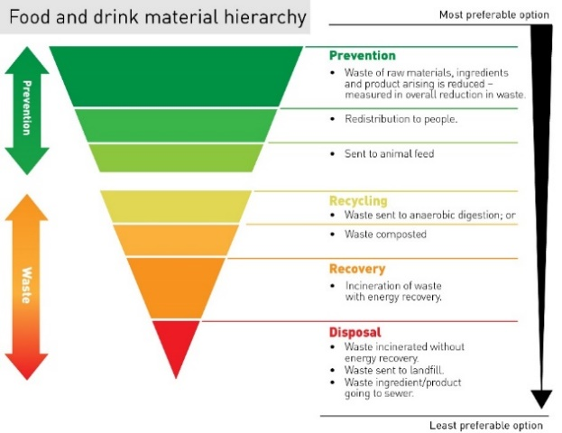

The food waste hierarchy, adopted in policy and legal frameworks across the European Union, including the UK, sets out five steps for dealing with waste, ranked according to their environment impact. If surplus cannot be prevented, redistribution to people is the preferred option, followed by converting to animal feed or fuel via anaerobic digestion. To tackle the problem that surplus food is not being used in the most socially and environmentally beneficial way, FareShare enables food companies to follow the food waste hierarchy and direct more surplus food to human consumption.
Thus, FareShare’s work redistributing surplus food for human consumption has the following environment impacts;
- Reduced CO2 emissions [11].
- Reduced wastage of surplus food and the resources related to its production [12].

These impacts lead to the reduced negative environmental impact of surplus food [17] in its broadest sense.
It should be noted that there may be other environmental factors to consider and the extent to which each impact happens as a result of FareShare’s work warrant further exploration.
This narrative will explore how FareShare’s activities may lead to the impact stated. We begin by exploring each of the activities to trace how they contribute to the previously stated end outcomes.

Impact
The impact is the broad societal change to which FareShare contributes with the recognition that other factors outside FareShare’s remit also play a role.
The ultimate impact FareShare seeks to achieve is two-fold:
- to maximise the social value of surplus food to better support individuals to improve their physical wellbeing, mental wellbeing, social inclusion, and food security [16].
- to reduce the negative environmental impact of surplus food [17].
These solutions both stem from the problem that surplus food is not being used in the most socially and environmentally beneficial way – going to waste in landfill, or being converted to animal feed or fuel. Meanwhile, charities and community groups struggle with increasing financial and practical pressures of providing food services to their beneficiaries. FareShare uses an innovative model to access and redistribute quality, in-date and good to eat surplus food that arises across the food industry to charities working with vulnerable or disadvantaged people throughout the UK.

Definitions and terms
The following definitions are used in this document and the accompanying map:
- Impact is the broad or longer-term effect of a project or organisation’s work that happen after outcomes have occurred. This can include effects on people who are direct users of a project or organisation’s work, effects on those who are not direct users, or effects on a wider field such as government policy. Specific projects or programmes often ‘contribute’ to impact, as other things can help bring about this long-term change.
- Outcomes are the changes, benefits, learning or other effects that happen as a result of a project or organisation’s work (its activities). Short term and intermediate outcomes are steps along the way to long-term outcomes; they need to happen before the more significant long-term outcomes can be achieved.
- Activities are the work undertaken to bring about these changes. They are products, services or facilities that result from an organisation's or project's work. They are the things it delivers in order to bring about change.
- Assumptions are all the ‘givens’ underlying the theory, without which the theory would not work. They might articulate key aspects of the approach or explanations of the links between outcomes. Some of these will be well-evidenced while others will need further testing and be therefore framed as questions.

There are also several terms used by FareShare to describe aspects of its work and its stakeholders:
- Regional Centres: FareShare distributes surplus food through 21 Regional Centres, of which it operates five. The others are run by independent charities who partner with FareShare in this work.
- Food partners are organisations from which FareShare sources surplus food for redistribution, such as retailers, manufacturers and suppliers.
- Food using organisations are the recipient organisations of the surplus food – Community Food Members (CFMs) that receive food from their local Regional Centre, or Community Food Affiliates (CFAs) that collect end-of-day surplus via FareShare Go.
- Beneficiaries refer to the beneficiaries of these recipient organisations (CFMs and CFAs).

Areas for further exploration

What do we mean by “quality and nutritional value”?
In outcome 5, FareShare has noted that it does not yet have a definition of quality and nutritional value of food. After that is established, more research is needed to see if and in what ways the food distributed by FareShare increases quality and nutritional value provided by food using organisations.

Food variety
There is little existing research on the wider benefits of experiencing new foods beyond the research of Dr Megan Blake. FareShare will look into exploring this area through qualitative data collection and reviewing any further research in this area to understand the additional benefits to individual lives from experiencing food they previously did not have access to.

Environmental benefit
FareShare’s model was designed with environmental benefits in mind. The core issue it is trying to solve is that surplus food is not being used in the most socially and environmentally beneficial way. The reduction of wasted surplus food via this model of food redistribution is less damaging to the environment than other uses for surplus food, such as converting it to fuel as stated in the Food Hierarchy displayed above.
However, the specific ways in which FareShare’s model produces environmental benefits different to that of other user models and the extent to which these benefits are materialised require further research.

A note about contribution to outcomes
It should be noted that FareShare’s direct beneficiaries are other organisations who in turn are better able to offer their own services thanks to the support of FareShare. Whilst some of FareShare’s outcomes are changes directly affecting these end beneficiaries (service users), such as having more nutritious food [9], outcomes arising from improved effectiveness of food using organisations are more linked to the organisations providing those services. FareShare should continue to critically assess which outcomes are ones it can attribute to its own work and which are ones it contributes to in this way.

More than just food: Food insecurity and resilient place making through community self-organizing, Megan K Blake, Sustainability April 2019 (11)

