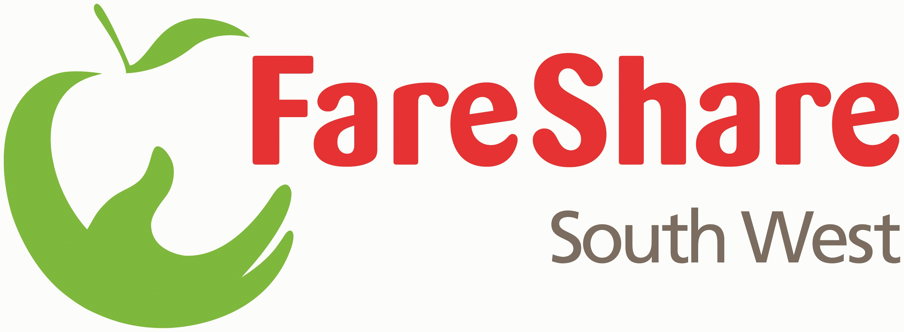
Job description

Job title: Warehouse Operations Manager (Devon & Cornwall)
Reporting to: Regional Manager
Salary £23,000 to £25,000 per annum
Hours: 37.5 hours per week
Terms: 1 year, Fixed Term Contract/Full-time, 25 days Holiday
(exc. Bank Holidays), 5% pension contribution
Responsible for: Operations Supervisors, Drivers & Volunteers

Circumstances:
- The role is based at Unit 4 Sisna Park Road, Estover, Plymouth PL6 7AE, but would be subject to working at other FareShare and partner locations across the South West.
- The role will include working hours during some evenings and sometimes at weekends.
- Usual working hours will be between 8.00 am – 5.00 pm, but the role could require evening shifts and flexible working hours.

- Application deadline: 20/06/2021
- Interview dates: 21/06/2021 & 22/06/21
- Expected start date: 02/08/2021
Purpose of role:
The role of Warehouse Operations Manager requires strong leadership in a constantly changing and growing environment of a food distribution charity. Creating structure and delegating accordingly is key within this role, where each day can vary with multi-layered activities. Working within a dedicated small staff team with a large pool of volunteers, many of whom have been or are vulnerable. The role requires sensitivity and empathy alongside discipline and boundaries. The successful candidate must have experience of working with vulnerable people, experience of food distribution, experience of developing operations and systems, experience of leadership.

About FareShare South West:
FareShare South West (FSSW) is part of the national FareShare UK network of surplus food redistribution charities. We fight food poverty by tackling food waste. We source quality surplus food from food retailers, manufacturers, and suppliers, engaging volunteers to redistribute to local charities and community groups that provide meals to vulnerable people (individuals who are homeless, unemployed, socially isolated, recovering from addictions, etc.). Our food is a vital lifeline for children and families, people on low incomes, people who have lost their jobs, the homeless, refugees, domestic abuse survivors, the elderly, and keyworkers. In 2020, we quadrupled our food output, delivering food for 4.1 million meals to frontline charities across the region.
FSSW is expanding their service into Devon and Cornwall working in partnership with local charities to provide vital food supplies across the region. This new and exciting role will play an important part of that ambition.
Duties & Responsibilities:
Strategic/Management:

- To oversee and manage the safe and efficient operation of a FareShare Southwest warehouse and satellite/sub-depots, ensuring that all essential tasks are completed to a sufficient level of quality.
- Working with the Regional Manager and the FSSW central team to ensure that the warehouse is effectively set up to manage levels of goods in and deliveries out to Members in line with agreed growth targets (in some cases beyond).

Working with the Regional Manager improve and evaluate existing operations and systems and develop and integrate new processes to ensure the ongoing success and growth of FareShare South West food depot

Maintain a strong leadership role which includes daily, weekly delegation to staff members and volunteers, feedback to team members, and holding team members to account.
- Responsibility for the management, training and supervision of an Operations Team made up of Operations staff members, secondee/placement/trainees, and key volunteers.
- Responsibility for volunteer workforce (usually a maximum of 10 on any particular shift) Working closely with the Volunteer Manager to ensure effective cover for shifts is in place and adequate/timely recruitment and support interventions are delivered.
- Responsibility for the day-to-day, on-site food safety, food hygiene, stock control, warehouse storage, delivery and collection logistics, food management systems (GLADYS & SalesForce), equipment, the warehouse site, and day-to-day management of the on-site fleet of FSSW vans.
- Responsibility for the health & safety, and security of the depot and the safety and wellbeing of all depot staff and volunteers.
- Responsibility for a budget and development of targets within the overall FSSW strategy and growth plan.
- Provide operational management/support to other FSSW locations as and when required e.g. 2nd depot, sub-Depots, partner operated locations.
- Accountability to the Regional Manager and one-to-one meetings, team meetings, and reporting against key performance indicators.
- Deputise for the Regional Manager as and when necessary.

Operational Management:

- Management staff members, including recruitment, training, appraisals, monthly supervisions and disciplinary procedures, working closely with the Operations Manager.
- Manage the daily Warehouse Task Checklist and operations of FSSW and develop new operations as required. All operations are in line with FareShare national policies and procedures and the needs of the local community
- Ensure the planning and smooth running of food intake and food delivered. Liaising with food industry representatives, FSUK Team, distribution companies, lorry drivers and volunteer drivers
- Ensure that all shifts are planned and filled, and be prepared to provide cover at short notice, including on very rare occasions driving the van. This could include covering evening shifts, Bank Holidays, and weekends
- Ensure that the vans used by FareShare South West are roadworthy, cleaned and legal, and deal with or report incidents and accidents while the van is on or off-site.
- Maintain good relations and communications with food suppliers and Community Member recipient projects in partnership with other team members, to high levels of customer care or stakeholder engagement.
- Monitor and evaluate the depot’s activities and make regular reports to the Operations Manager, other team members, The Directors of FSSW and FareShare National as required.
- Manage the filing, storage and archiving of daily operational paperwork.
- Ensure the depot is ready for and compliant with the annual NSF Audit, corrective actions are taken on time, and the depot remains compliant to the highest standards throughout the year.
- Ensure that at all time, the depot has adequate supplies of essential consumables and equipment for the day-to-day running of the site.
- Ensure the depot is clean and tidy in line with the FareShare Food Safety manual, the cleaning rota, and management of any external contractors.
- Manage waste and maximise the distribution of surplus food through the Food Allocation tool on a daily basis, clearance, and daily offers.
- Manage on-site petty cash

Volunteer Programme, working closely with the Volunteer Manager:

- Ensure that all volunteers and staff are trained as appropriate
- Take responsibility for volunteer welfare and safety within warehouse operations and logistics
- Be involved with the ongoing development and delivery of volunteer policies and evaluation
- Be involved with other training needs such as NVQ, Basic Skills, Forklift Training, DIPSW
- Responsibility for the management and delivery of corporate volunteer days
- Ensure that the workforce on any given day has an adequate mix of trained personnel to align with safe and effective operations (e.g. enough trained forklift drivers)
- Ensure adequate volunteer records are kept and that any shortages are predicted and acted upon to ensure a viable workforce is in place for every shift.

Health & Safety, Food Safety and Equal Opportunities:

- Operate according to the FareShare HACCP Food Safety Manual
- Take responsibility for the day to day health & safety, and security of the warehouse operations
- Support the development of policies, risk assessments and procedures for the depot and ensure that all staff, volunteers, donors, recipients and visitors adhere to them as appropriate
- With other the Regional Manager, be responsible for management and training aspects of relevant industry standards
- Take responsibility for food safety within the depot, ensuring appropriate training is given and all guidelines and legal requirements are adhered to
- Ensure the service is delivered in accordance with the FareShare Equal Opportunities Policy
- Carry out any other duties which may be necessary to fulfil the main purpose of the post
Person Specification

Essential knowledge, skills & experience – evidence required:
- At least 2 years experience of working in at least two of the following areas: voluntary sector management, food distribution, warehousing operation management
- Experience of recruiting, supervising/managing staff and volunteers
- Ability to develop, initiate and maintain systems and procedures
- Experience of a complex warehouse operation
- Excellent communication and interpersonal skills
- Experience of Team leading, able to motivate and develop people through positive approaches, and experience of working with people who require support
- Ability to delegate to and manage a team of workers, line management and supervision
- Good administrative and organisational ability
- Problem solver and competent decision maker
- Full UK driving licence
- IT literate with a working knowledge of Microsoft Office applications
- A clear commitment to the ethos of FareShare South West, and to the agreed plans of the organisation, and able to positively contribute towards its achievement
- Experience of taking responsibility for health and safety issues within a food distribution and/or warehousing operation
- Experience of driving vans/medium sized vehicles
- Fork Lift Truck operators’ qualification

Desirable knowledge, skills & experience:

- Training skills
- Presentation skills

Willing to train to:

- Intermediate Food Hygiene qualification
- Health & Safety qualification
- Management qualification/skills (general/warehouse/operations/logistics)

Please send your CV and covering letter to: shelley.wright@fareshare.org.uk by 12pm on Sunday 20th June. Interviews will be held on Monday 28th and Tuesday 29th June.

Debit card: Mr C B Mason - FareShare South West - 4988 2430 7524 6045 VISA 09/20 – 10/23 – 611

Invoice: Charis

Network
James

